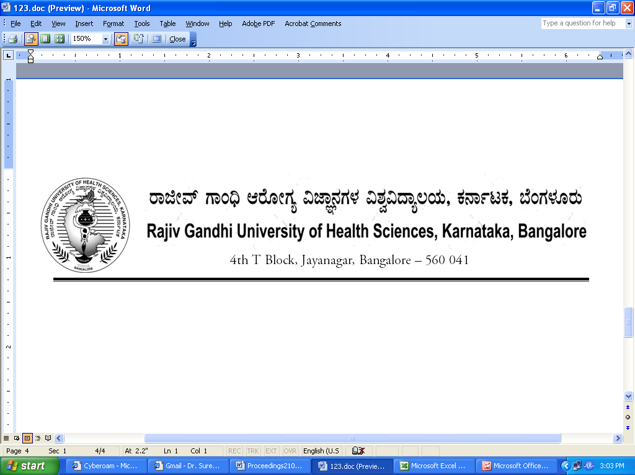

Dr.M.K.Ramesh Ph: 080-26961903, 26961946, Fax: 26961931
Registrar (Evaluation) Email: registrareva@rguhs.ac.in

Reg[E]/Exam/April- 2018 Dated: 24/01/2018

REVISED NOTIFICATION

The application for online submission of dissertation of M.Sc Nursing is ready.

Sl No. | Name of the Events | Stream
1. | Dissertation – Submission to RGUHS  Last date for submission without fine | 10th February -2018
2. | Dissertation Submission with  a. Fine of Rs 1.500/- per candidate till | 11th February- 2018  To  20th February-2018
2. | b. Fine of Rs 4.000/- per candidate from | 21th February- 2018  To  28th February- 2018

The PG students should register and then upload the dissertation as per the instruction provided there all the dissertations of 2015-16 shall be compulsory submitted through web application only. The website address is as follows rguhs.ac.in/Examination/Online Thesis submission

By Order

Sd/-
Registrar (Evaluation)
To,

The Principal of all the concerned affiliated colleges.

